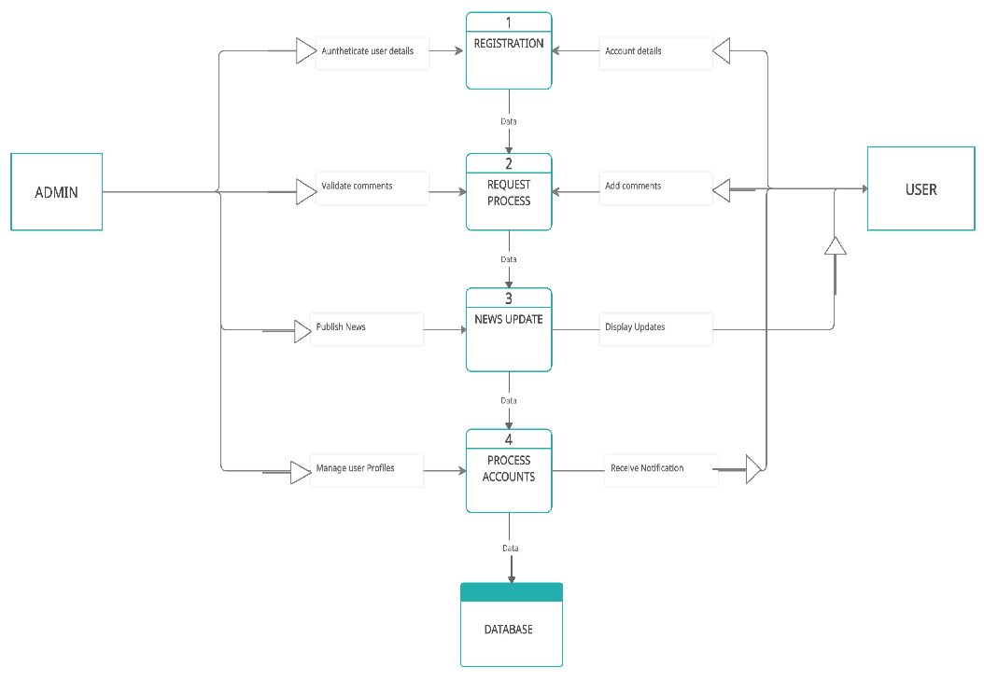

**Example: DFD Level 0 (Industry Standard)**

**Project Design Phase-II Data Flow Diagram &User Stories**

|  |  |
| --- | --- |
| **Date** | 15 October 2022 |
| **Team ID** | PNT2022TMID33344 |
| **Project Name** | News Tracker Application |
| **Maximum Marks** | 4 Marks |

**Data Flow Diagrams:**

A Data Flow Diagram (DFD) is a traditional visual representation of the information flows within a system. A neat and clear DFD can depict the right amount of the system requirement graphically. It shows how data enters and leaves the system, what changes the information, and where data is stored.

**Example:**

Input

data

data stored in database

User

Request

Processing

request

**User Stories**

|  |  |  |  |  |  |  |
| --- | --- | --- | --- | --- | --- | --- |
| **User Type** | **Functional Requirement**  **(Epic)** | **User Story**  **Number** | **User Story / Task** | **Acceptance criteria** | **Priority** | **Release** |
| Customer (mobile user) | Registration | USN-1 | As a user, I can register for the application by entering my email, password, and confirming my password. | I can access my account / dashboard | High | Sprint-1 |
|  |  | USN-2 | As a user, I will receive confirmation email once I have registered for the application | I can receive confirmation email & click confirm | High | Sprint-1 |
|  |  | USN-3 | As a user, I can register for the application through sign up with google | I can register & access the dashboard with Gmail or in  Browser Login | Medium | Sprint-1 |
| Customer (Web user) | Login | USN-4 | As a user, I can log into the application by entering email & password | I can view all types of informations through this  application | High | Sprint-1 |
|  | Dashboard | USN-5 | As a user , I can edit Profile to update my personal data | I can view that personal data got updated | High | Sprint-2 |
|  |  | USN-6 | I want to read news based on my filter contents | News contents are filtered based on user | Medium | Sprint-2 |

|  |  |  |  |  |  |  |
| --- | --- | --- | --- | --- | --- | --- |
| **User Type** | **Functional Requirement (Epic)** | **User Story Number** | **User Story / Task** | **Acceptance criteria** | **Priority** | **Release** |
| Customer Care  Executive | Help | USN-7 | Get weekly report of user reviews | I can monitor the effectiveness of user  review | High | Sprint-2 |
| Administrator | Admin access | USN-8 | As a system admin i want to able to configure user settings so that i can controll access | Access controll by system admin initiated | High | Sprint-2 |